Spectroscopic properties of novel rare-earth-doped glasses for photonic applications
Alberto Saggio^{1*} and Albert Wise²
¹ Glassy Materials Lab, Institute of Research, 50999 Vetropaese, Italy
² Department of Glass Science, University of Glass, 80718 Glasstown, Glasscountry
* alberto.saggio@com.com

Keywords: indicate up to three keywords

In the optical telecommunication based on the wavelength-division-multiplexing (WDM) system [1], in the optical telecommunication based on the wavelength-division-multiplexing (WDM) system in the optical telecommunication based on the wavelength-division-multiplexing (WDM) system in in the optical telecommunication based on the wavelength-division-multiplexing (WDM) system in the optical telecommunication based on the wavelength-division-multiplexing (WDM) system the in the optical telecommunication based on the in the optical telecommunication based on the wavelength-division-multiplexing (WDM) system.
In the optical telecommunication based on the wavelength-division-multiplexing (WDM) system in the optical telecommunication based on the wavelength-division-multiplexing (WDM) system in the optical telecommunication based on the wavelength-division-multiplexing (WDM) system in the optical telecommunication based on the wavelength-division-multiplexing (WDM) system in the optical telecommunication based on the wavelength-division-multiplexing (WDM) system.
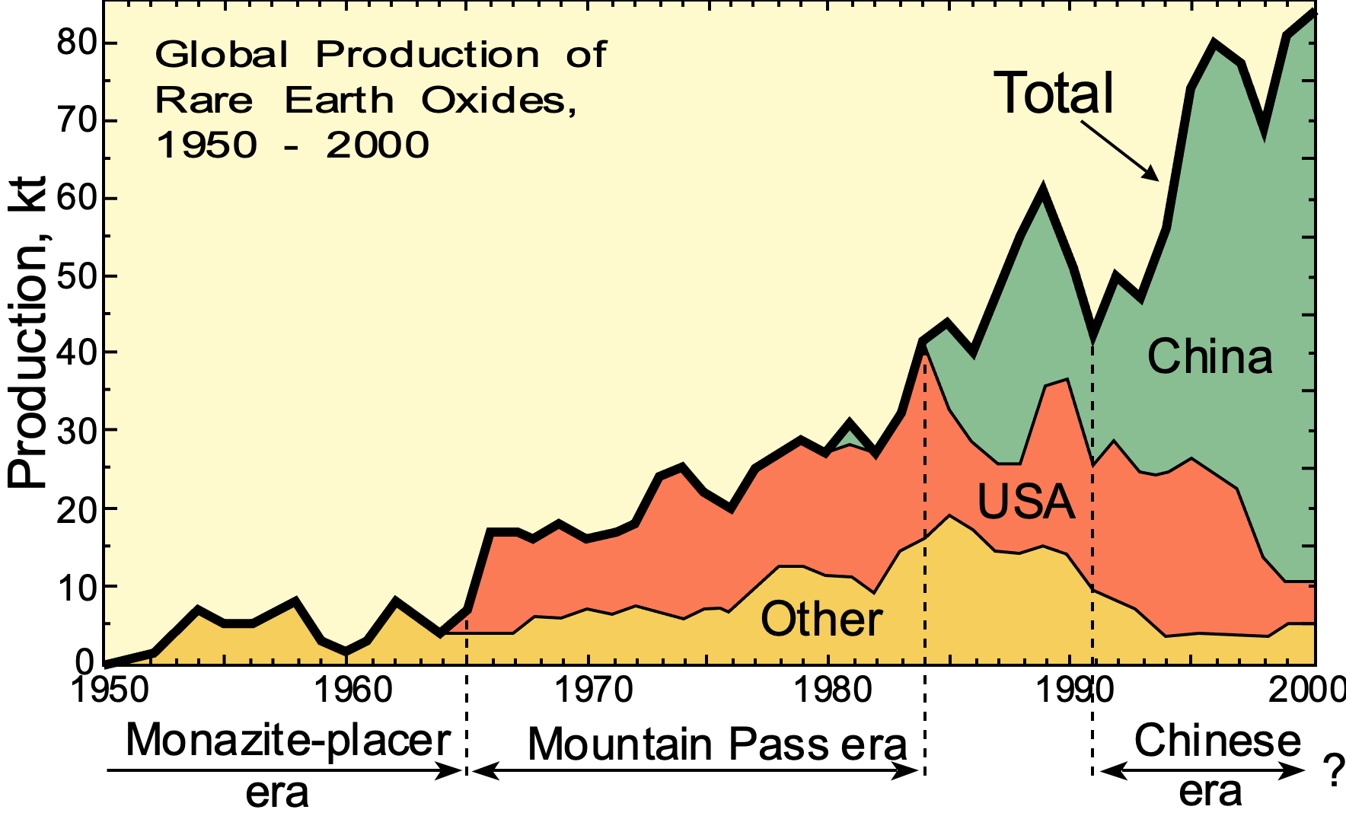Fig. 1. Global production of rare earth oxides 1960 to 2000.
Reproduced from Wikipedia..

DO NOT EXCEED ONE PAGE, INCLUDING FIGURES, IF ANY
Title Font: Times New Roman bold, 12 pts; authors: Times,11 pts.bold
Text Font: Times New Roman, 10 pts
Top and bottom page margins: 2.0 cm – side margins: 2.5 cm

In the optical telecommunication based on the wavelength-division-multiplexing (WDM) system the optical telecommunication based on the wavelength-division-multiplexing (WDM) system the optical telecommunication based on the wavelength-division-multiplexing (WDM) system the optical telecommunication based on the wavelength-division-multiplexing (WDM) system the optical telecommunication based on the wavelength-division-multiplexing (WDM) system the optical telecommunication based on the wavelength-division-multiplexing (WDM) wavelength-division-multiplexing (WDM) system the optical telecommunication based on twavelength-division-multiplexing (WDM) system the optical telecommunication based on twavelength-division-multiplexing (WDM) system the optical telecommunication based on twavelength-division-multiplexing (WDM) system the optical telecommunication based on twavelength-division-multiplexing (WDM) system.
In the optical telecommunication based on the wavelength-division-multiplexing (WDM) system in the optical telecommunication based on the wavelength-division-multiplexing (WDM) system in the optical telecommunication based on the wavelength-division-multiplexing (WDM) system in the optical telecommunication based on the wavelength-division-multiplexing (WDM) system in the optical telecommunication based on the wavelength-division-multiplexing (WDM) system.
In the optical telecommunication based on the wavelength-division-multiplexing (WDM) system in the optical telecommunication based on the wavelength-division-multiplexing (WDM) system in the optical telecommunication based on the wavelength-division-multiplexing (WDM) system in the optical telecommunication based on the wavelength-division-multiplexing (WDM) system.

References
[1] W. Blanc, Y. G. Choi, X. Zhang, et al., The past, present and future of photonic glasses: A review in homage to the United Nations International Year of glass 2022, Progress in Materials Science, 134, 101084 (2023). DOI: 10.1016/j.pmatsci.2023.101084.

